2. Online Hotel Room Booking System
Aim: To develop a hotel booking website for searching rooms, checking availability, and managing reservations.
Algorithm:
- Start the website and display the home page.
- Allow users to register and log in.
- Enter the destination, check-in date, and check-out date.
- Display available rooms with prices and facilities.
- Select a room, enter guest details, and confirm the booking.
- Display the booking confirmation and allow users to manage reservations.
Program:
<!DOCTYPE html>
<html>
<head>
<title>Hotel Room Booking</title>

<style>
body{
font-family:Arial;
margin:0;
background:#f2f2f2;
}

header{
background:#0077b6;
color:white;
text-align:center;
padding:15px;
}

nav{
background:#023e8a;
padding:10px;
text-align:center;
}

nav a{
color:white;
text-decoration:none;
margin:15px;
font-weight:bold;
}

section{
background:white;
width:80%;
margin:20px auto;
padding:20px;
border-radius:8px;
box-shadow:0 0 5px gray;
}

input,select,textarea{
width:100%;
padding:10px;
margin:8px 0;
}

button{
background:#0077b6;
color:white;
padding:10px 20px;
border:none;
cursor:pointer;
}

button:hover{
background:#023e8a;
}

table{
width:100%;
border-collapse:collapse;
margin-top:10px;
}

table,th,td{
border:1px solid black;
}

th,td{
padding:10px;
text-align:center;
}

footer{
background:#0077b6;
color:white;
text-align:center;
padding:10px;
}
</style>

</head>

<body>

<header>
<h1>Hotel Room Booking System</h1>
</header>

<nav>
<a href="#home">Home</a>
<a href="#register">Register</a>
<a href="#login">Login</a>
<a href="#rooms">Rooms</a>
<a href="#booking">Booking</a>
<a href="#history">History</a>
<a href="#admin">Admin</a>
<a href="#contact">Contact</a>
</nav>

<section id="home">
<h2>Welcome</h2>
<p>Book hotel rooms easily and manage your reservations online.</p>
</section>

<section id="register">
<h2>User Registration</h2>

<input type="text" placeholder="Full Name">

<input type="email" placeholder="Email">

<input type="password" placeholder="Password">

<button onclick="alert('Registered Successfully')">Register</button>

</section>

<section id="login">
<h2>User Login</h2>

<input type="text" placeholder="Username">

<input type="password" placeholder="Password">

<button onclick="alert('Login Successful')">Login</button>

</section>

<section id="rooms">

<h2>Room Availability</h2>

<input type="text" id="search" placeholder="Search Room Type">

<button onclick="searchRoom()">Search</button>

<p id="result"></p>

<table>

<tr>
<th>Room Type</th>
<th>Price</th>
<th>Status</th>
</tr>

<tr>
<td>Standard</td>
<td>₹1500</td>
<td>Available</td>
</tr>

<tr>
<td>Deluxe</td>
<td>₹2500</td>
<td>Available</td>
</tr>

<tr>
<td>Suite</td>
<td>₹4000</td>
<td>Booked</td>
</tr>

<tr>
<td>Luxury</td>
<td>₹6000</td>
<td>Available</td>
</tr>

</table>

</section>

<section id="booking">

<h2>Book Room</h2>

<input type="text" placeholder="Name">

<select>
<option>Standard</option>
<option>Deluxe</option>
<option>Suite</option>
<option>Luxury</option>
</select>

<input type="date">

<input type="number" placeholder="Guests">

<button onclick="alert('Room Booked Successfully')">Book Room</button>

</section>

<section id="history">

<h2>Booking History</h2>

<table>

<tr>
<th>Room</th>
<th>Date</th>
<th>Status</th>
</tr>

<tr>
<td>Deluxe</td>
<td>10-08-2026</td>
<td>Confirmed</td>
</tr>

</table>

<button onclick="alert('Booking Modified')">Modify Booking</button>

<button onclick="alert('Booking Cancelled')">Cancel Booking</button>

</section>

<section>

<h2>Payment</h2>

<input type="text" placeholder="Card Number">

<input type="text" placeholder="Card Holder Name">

<button onclick="alert('Payment Successful')">Pay Now</button>

</section>

<section>

<h2>Reviews</h2>

<textarea placeholder="Write Your Review"></textarea>

<button onclick="alert('Review Submitted')">Submit Review</button>

</section>

<section id="admin">

<h2>Admin Login</h2>

<input type="text" placeholder="Admin Username">

<input type="password" placeholder="Password">

<button onclick="alert('Admin Login Successful')">Login</button>

<h2>Room Management</h2>

<input type="text" placeholder="Room Type">

<input type="number" placeholder="Price">

<input type="number" placeholder="Quantity">

<button>Add / Update Room</button>

</section>

<section>

<h2>About Us</h2>

<p>Our hotel offers comfortable rooms with modern facilities and excellent customer service.</p>

</section>

<section>

<h2>Customer Service</h2>

<p><b>Q:</b> Can I cancel my booking?</p>

<p><b>A:</b> Yes, up to 3 days before arrival.</p>

</section>

<section>

<h2>Travel Guide</h2>

<p>Nearby attractions, bus station, railway station and airport information.</p>

</section>

<section>

<h2>Privacy Policy</h2>

<p>Your booking information is kept safe and secure.</p>

</section>

<section id="contact">

<h2>Contact Us</h2>

<input type="text" placeholder="Your Name">

<input type="email" placeholder="Email">

<textarea placeholder="Message"></textarea>

<button onclick="alert('Message Sent Successfully')">Send</button>

</section>

<footer>

<p>© 2026 Hotel Room Booking System</p>

</footer>
<script>

let rooms=["Standard","Deluxe","Suite","Luxury"];

function searchRoom(){

let search=document.getElementById("search").value.toLowerCase();

let found=rooms.find(room=>room.toLowerCase().includes(search));

if(found){

document.getElementById("result").innerHTML="Room Available: "+found;

}
else{

document.getElementById("result").innerHTML="Room Not Found";

}

}

</script>

</body>
</html>

Result: Thus, the Hotel Booking System was designed to search available rooms and manage hotel reservations.
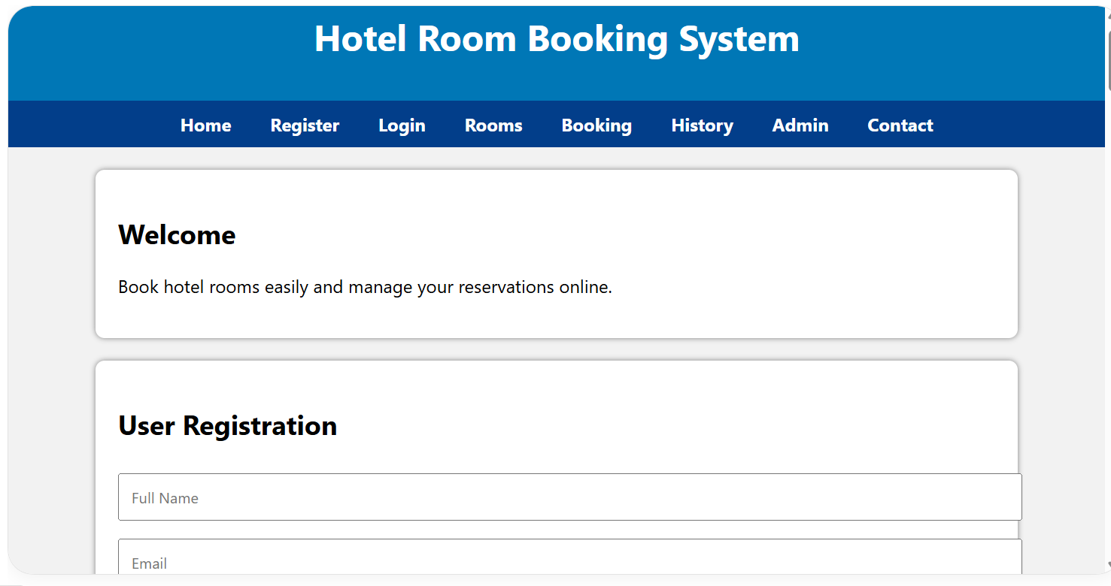
Output:

